Relations in Tryton XML

Tryton, a free/open-source ERP (Enterprise Resource Planning) system, utilizes XML files to define its data model, including relations between different entities. These relations establish connections between data points, enabling you to create a structured and interconnected database schema.

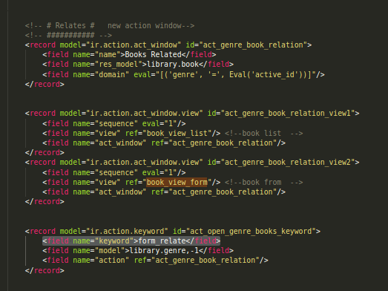
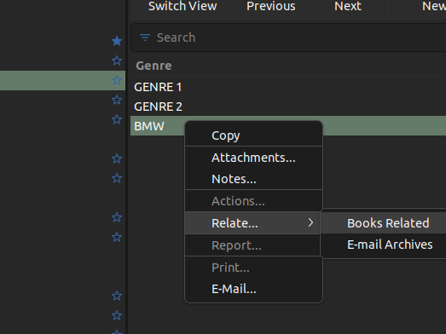

All of those xml lines must to have a relation between them, which makes it easy to create relational data in databases.

In this case, all the data in (library.book) list and form is linked in the genre (form_relate).

The value (form_relate) for the keyword field of the ir.action.keyword instance. This is used to tell tryton that the action should appear under the Relate menu in the toolbar. Relates should fall under this menu, and are usually defined as anything that opens a new tab to show related informations to the selected records.

The domain field on the ir.action.act_window model. Now you should be able to guess what it means: We want to force a constraint (domain) on the records that are displayed in the tab. The value is not passed as a string (like for instance in the res_model field) but in the eval parameter, with the pyson attribute set to "1". Doing so will make tryton parse the value as a Pyson expression (which it is because of the use of Eval), and stored it in a serialized way in the database (we cannot store the Eval class directly in the database). You should remember what active_id is from the previous step: it contains the id of the currently selected record in the client.

So what we are doing here is adding a new entry point under the Relate menu for the library.genre model. When activated, it will open a new tab, in which will be displayed all the books which are related to this genre.

Relates are very interesting because:

>They allow you to display data related to a record even
if the number of elements in the list is huge. Also, it comes
with all the filtering tools of standard ir.action.act_window tabs.

>They are directly available in the "right-click" menu of a record.

>They provide for a way to lighten your form views by showing big lists
in separate tabs.

TAB DOMAINS
Another thing you may want to do is to have separate tabs in a given tab. We will do this for books, in library.xml.
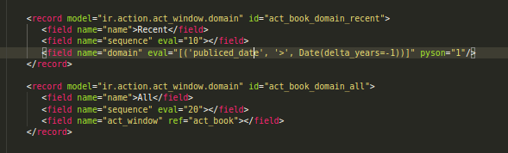
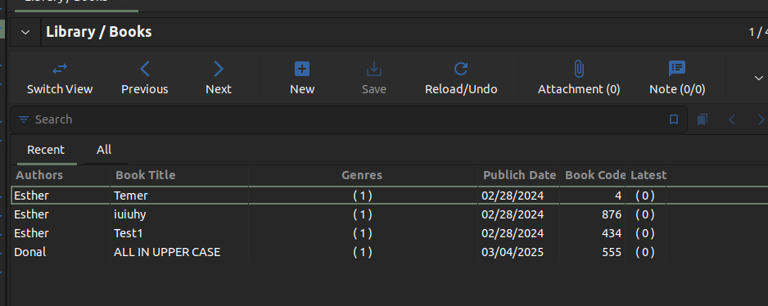

You can probably guess where this is going. The ir.action.act_window.domain records define domains on the ir.action.act_window model. Those will be converted to "sub-tabs" in the "main tab" of the action. The contents of the tabs will be defined by the domain contents. Here, thefirst tab will be limited to books which were published in the past year (Date(delta_years=-1) means the current date minus a year), while the second will have no limitation at all.

Buttons
You can check it out in the form view. The string will be displayed alongside the icon, and you can click on it (its a button). However you will be greated by a cryptic error message about create_comment being a method that you are not allowed to call on library.book.

Buttons must be bound to methods defined in the model on which the button is displayed. Also, not any method will do. Add the following in library.py under the library.book model.

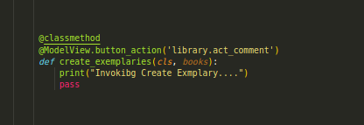

The prototype for "button" methods is a classmethod which accepts a list of instances.
This line is used to explain to tryton what should happen when the button is clicked. The ModelView.button_action decorator is used to bind the method to the action given as a parameter. What we are basically saying here is that the create_exemplaries button, when clicked, should open the act_comment, which is bound to the wizard we created in the previous state. In this case, the body of the method will be left empty.

When click the button it will still have an error mensssage. That is because by default tryton forbid all and few method when they are called they are reject, whe need to confirm this method in the __setup__ so our model knows that this button is action of ours.
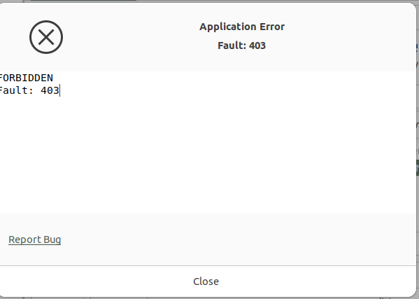
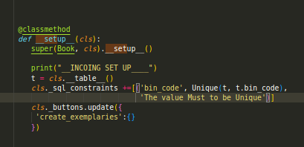

we can use that object behind the name of the method to add dynamicity in our method such as like read onlym or invisble etc.

Special Methods
Server Method
__setup__
> You may know a lot about “__setup__ “but there a more that you need to know, What you need to remembered is that usually you will use it to set “model” attributes that have special meaning in tryton.
The __setup__ method is called very early in the server startup, so something like pool are no available in that line of time. And you should not try to access to the database unless you know what are doing.

__register__
This’s is often used, but not when creating module: The main use case for overriding it is to manage automatic version upgrade of your modules.
Internally the __register__ method is responsible for creating/updating the database table bound to a record (adding new columns, etc), installing translation etc. It is called when the module is installed or upgraded.

CRUD METHODS:
It Stand for Createm Read, Upgrade, Delete, those are basic method not just in tryton also in many frameworks that stand for this way in retriving and updating data over the network.

CREATE: It’s invoke when a record is saved.
READ: Use to get field value form a record in the displayed in the view, once this’s displayed it will call the read method.
WRITE: When modify an instance, and saving modification, the write method is invoked.
DELETE: When delete an instance.
SAVE: This’s a shortcut for either creation or writing, it depend of the state of the record, if it was already saved, modification that were made will be written, else it will be created.
VALIDATE: This is called every time a record is modified, whether it is through → create or → write. It will not called if you directly update the database through SQL.

THE view_attributes, is used to add dynamicity to specific views in the application. For instance, you may want to hide a whole group in a view depending on the values on that field e.i:

